Setting Up Application Environment

DOCKER INSTALLATION

|  |  |
| --- | --- |
| Date | 11 November 2022 |
| Team ID | PNT2022TMID42604 |
| Project Name | SMART FASHION RECOMMENDER APPLICATION |
| Team Members | Sangamitra S  Sathish M  Tharini Mala S K  Venkat Raman P |

**Docker Installation:**

**Step 1:**

1.1 As you find Install Docker CLI in the IBM account and follow the steps in it.

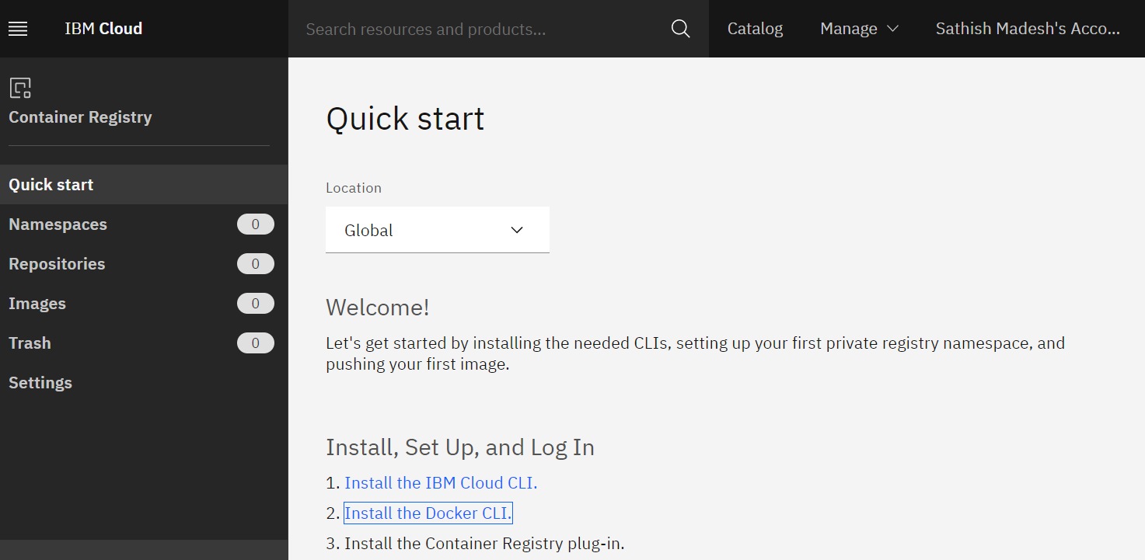

1.2 It will lead you to Docker website [*https://docs.docker.com/desktop/install/windows-install/*](https://docs.docker.com/desktop/install/windows-install/)

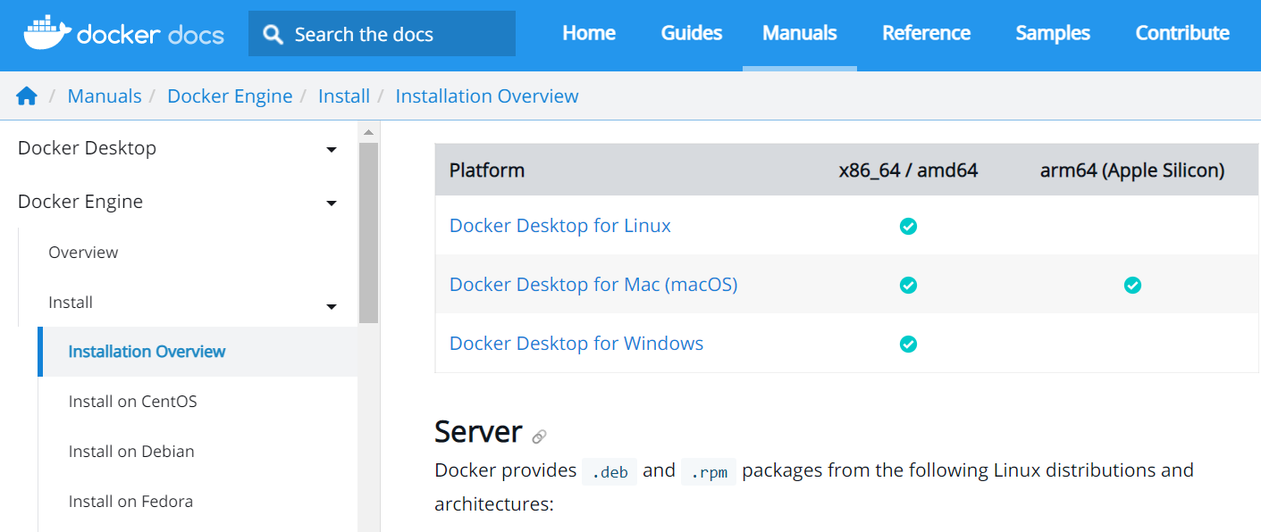

1.3 Click and start downloading the file (might take time while download)

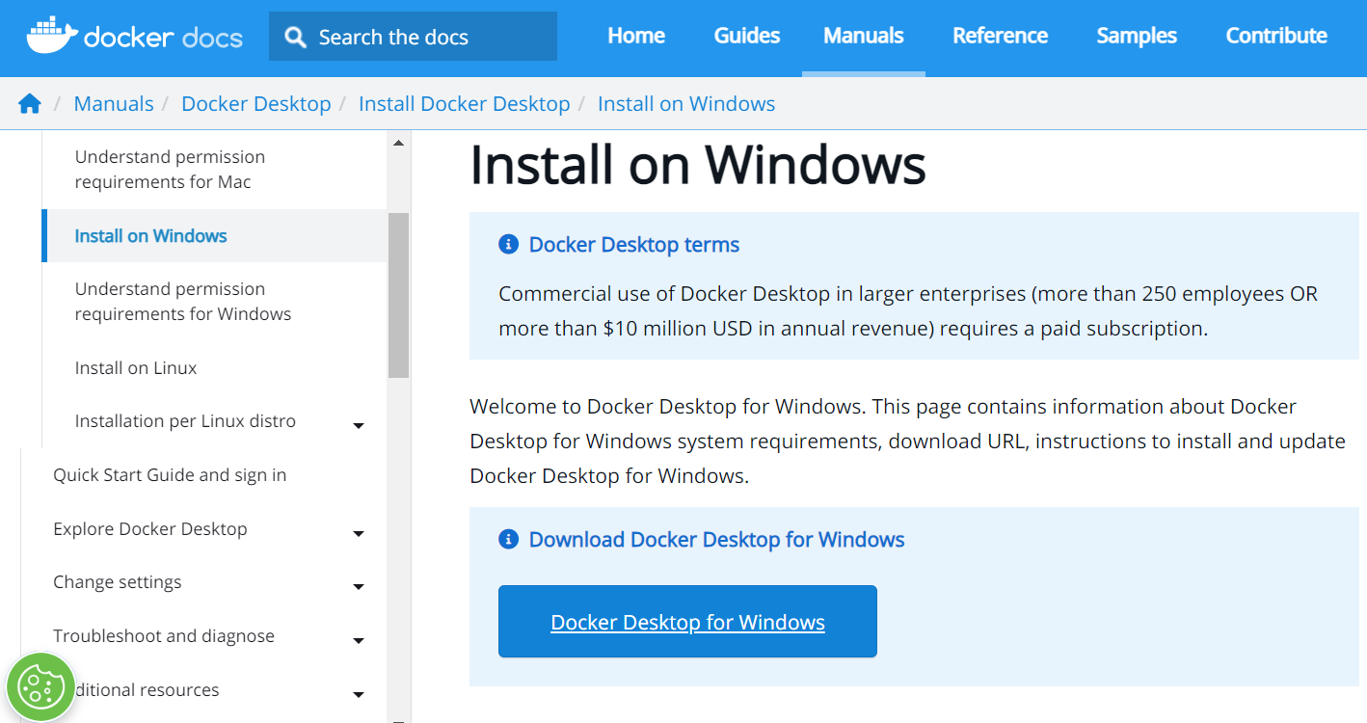

**Step 2:**

You can go to downloads or in folder & double-click the particular Docker File.

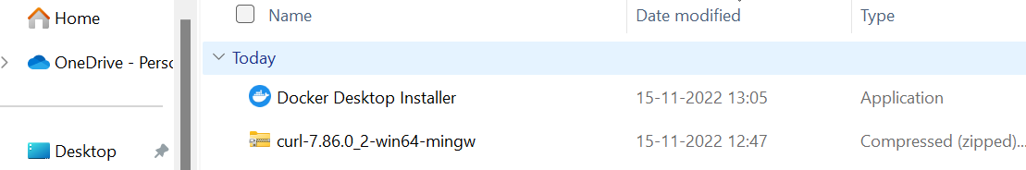

**Step 3:**

It will installed . You can register and login that app to access those credentials.

**Step 4:**

Docker will start correctly, the left bottom of the desktop in success message & shows the status of docker app working successfully.

**Step 5:**

Finally, the Docker is installed successfully.